II.3.C. The Japanese Game of Mah-Jongg

In describing the Japanese rules and how we will implement them, I first examine the screen layout (how we will display the game, which involves a good part of the user interface), then the features and user-selectable options of Japanese Mah-Jongg as implemented in Shanghai: Dynasty.

II.3.C.1. The Japanese screen layout

The screen layout for Japanese MJ is different from that we are using for Chinese and American MJ. Below is a picture of how the Japanese game screen is laid out.

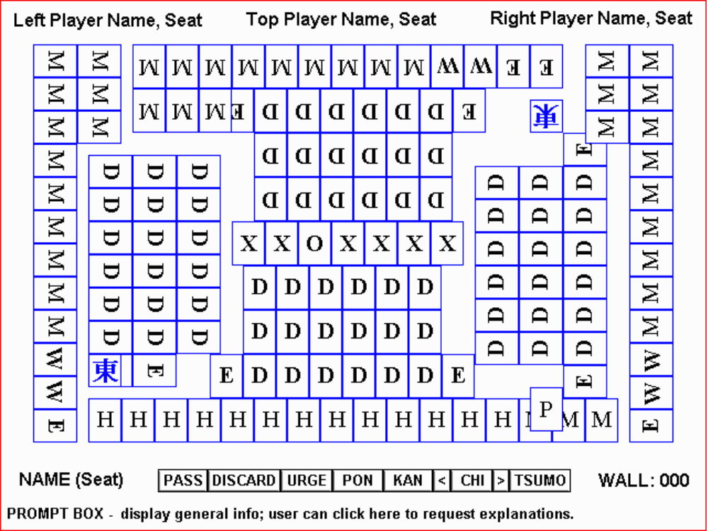

KEY:

P - The current Picked tile goes here immediately after being drawn from the wall.
H - The tiles in the Hand go here (as tiles are melded, they will occupy this area from L to R).
M - The Melds go here (user's Picked tile shifts left).
X - The Dead Wall (can be shown two tiles deep, or, if necessary, just one tile deep).
O - The Dora tile goes here, face up.
W - This is where the Winning opponent's final pair goes after going out (snug to nearest meld).
D - Discard area (designed so that normally the Wall is empty before these are all filled).
E - Expansion space to accommodate extra discards or rotated tiles. Note: we may forego these "horizontal" expansion spaces entirely, making a straightforward 18-tile discard area. All extra discards beyond 18 can then be stacked, necessitating the use of the X-Ray button as was done in Chinese/Western MJ.

This screen layout is designed to allow the largest possible tile size (30x40 pixels on a 640x480 pixel screen). Please bear with me through a description of the screen layout and all its implications, before getting into the actual game itself.
Readers of the complete design will notice that the interface button array is labeled somewhat differently from the Chinese and American games.
For one thing, the X-Ray button is not needed in the Japanese game (unless the Dead Wall is two tiles deep and the top layer obscures the opposing player's discards, and we decide to put the X-Ray button back).
Secondly, the terminology for Pongs, Kongs, and Chows is different in Japanese MJ.

Chinese American Japanese
PONG TRIPLE PON
KONG QUAD KAN
CHOW SEQUENCE CHI
WIN WIN TSUMO
WIN WIN RON
WIN WIN IPPATSU
WIN WIN RIICHI

Thirdly, the Win button is shown labeled "Tsumo." This label will change to match the circumstances. If the user has an opportunity to go Out on a self-picked tile, the button is labeled "Tsumo." If the user has an opportunity to go Out on a discard, the button is labeled "Ron." If the user has an opportunity to go Out one turn after having declared Reach, the button is labeled "Ippatsu." In Chinese/Western MJ, the Pass button changes to a Draw button at the beginning of a player's turn. Similarly, in Japanese MJ, the Win button should change for certain circumstances. The button should change and display the following words:

WIN
RON
TSUMO
IPPATSU
REACH

There are 2 ways we could handle the Win button (I will accept the one that QSI prefers strongly, otherwise I can state my preference).
A. The Win button never says "Win" at all. It normally says "Ron" or "Tsumo" during play, depending on whose turn it is. It could be a way of illustrating the meaning of the two terms for the player if the button always says "Ron" while other players are discarding and "Tsumo" when it's the player's turn to discard -- even though the button is not lit up. Or that might look confusing since the button is not lighting up.
B. If it is too difficult to do "A," or if it is deemed that in coming up with "A" I must've been smoking crack, then the button could simply say "Win" when it's not lit up. When the button lights up, it changes to "Ron," "Tsumo," "Reach," or "Ippatsu" as outlined below.

RON -- The Win button should definitely read "Ron" and light up when an opponent discards a tile which the player can legally take to win on that discard.

TSUMO -- The Win button should read "Tsumo" and light up when the player has drawn a tile which lets him win.

RIICHI -- The Win button should read "Reach" and light up when the player is holding a fishing (calling) hand and an appropriate discard is highlighted. This could be complicated -- please bear with me. Let's say I have a fishing (calling) "Pure" hand ("Chinitsu") -- all Bams and one Dot. When I have the sole Dot tile highlighted and raised, the Win button should say "Reach" and light up. But if I move the highlight off the Dot tile, to a tile which if discarded would not leave me with a fishing hand, then the Win button becomes unlit (still says "Reach").

IPPATSU -- After declaring Reach, the Win button (even if not highlighted) should change and read "Ippatsu" for the next turn around the table. If play goes around the table and back to the player without the player having seen the winning tile, then the Win button should cease reading "Ippatsu" and now read "Tsumo" (while it's the player's turn) or "Ron" (while it's an opponent's turn) or "Win" (if I was smoking crack to suggest "A").
Note: this "Ippatsu" action of the button only applies if the "Ippatsu" option is On (it defaults to On but the user might turn it off).

Several more things to mention about the Japanese screen layout.
In our Chinese and American games, we place melded pongs, kongs, and chows to the left, and Flowers to the right (in keeping with the way this is done in "Hong Kong Mahjong," "Four Winds," and "Mah Jong Parlour"). It is, however, standard Japanese practice to place the melds to the right (there are no Flowers in the Japanese game). So our meld area will necessarily expand into the place where (at the beginning of the game) the user's most recent Pick is displayed. As the hand shrinks (due to tiles being melded on the table) towards the left, the Pick location has to move accordingly (as opposed to how we do this in Chinese and American, where the Pick location is stationary and the left end of the hand moves to the right).
The discards area is designed specifically to conform to standard Japanese MJ practice. It is expected that a player's meld area normally needs to accommodate 18 discards. Therefore it is standard to make either 2 rows of 9 tiles (which we cannot do for the left and right players, given the small size of our table and the large size of our tiles) or 3 rows of 6 tiles (the method I have chosen). But note that when a player declares Reach, the discarded tile must be turned sideways, which kind of messes up the discard area -- in other words, although I show a neat grid in the picture at the beginning of this section, the reality of playing will not stay exactly within the lines.
One additional complication which our discard area needs to accommodate is the possibility that a player's discards may exceed 18 (most likely will not go over 20 tiles). Only a player whose melds exceed other players' melds is likely to have this happen -- so this will not happen to all four players (at most to two players, I expect). If we do not have enough space to add 2 tiles to the right of the third (bottom) row of 6 tiles, then we may have to shift everything in that player's discard area to make room. This messiness is only temporary (the game is bound to end soon, at this point) and is illustrated later on in this document.
Note: it is now assumed that Dan will prefer to leave the discard area at 6x3 and simply stack extra discards, as was done in Chinese/Western MJ. This is OK. It does of course necessitate the inclusion of the X-Ray button, which must function the same way it did in Chinese/Western. The following paragraph can be ignored if Dan chooses to go this way.
The need to be flexible in this way is part of the reason why the discard area is offset (the tiles in the discard area at the bottom of the screen do not line up with the tiles in the player's hand -- and the tiles in the discard area at the bottom of the screen do not line up with the tiles in the discard area at the top of the screen). Each discard area needs some buffer space to its right, because a tile may need to be rotated in any row. Another reason for the offset is to more clearly delineate the discards from the tiles in the hand.
The Wind marker is used to clearly identify what round it is; and it faces the player who dealt at the beginning of the round. We can place the marker at two possible locations on the table -- each position allows two possible facing directions for the marker, in case the marker should also indicate a particular player. In the Japanese game of MJ, only the East and South rounds are played (the West and North rounds are not played; a complete game is therefore half as long as a Chinese or Western game).
Given the Japanese practice of "marking" melds by turning a tile sideways, our meld areas all need to allow for this. I don't think the practice has an English name (I have no idea if it has a Japanese name since it's "just the way it's done"), so it bears explanation. Below are examples of (1) the Chinese/Western way of melding, and (2) what the same melds would look like if marked Japanese-style.

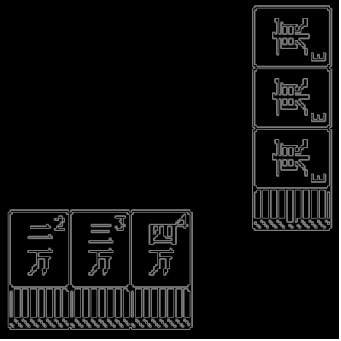

In the bottom of the above illustration, we see a melded Chow as it appears to the player who made the meld ("you"). Without the Japanese "mark," nobody can tell which tile was taken from another player's discard. At the right side of the picture we see the next player's melded Pong of East Winds.

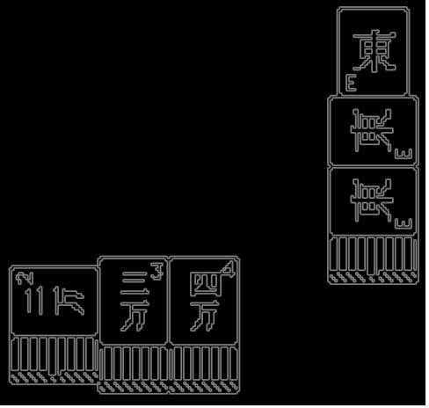

In the Japanese game, when you make a Chow from another player's discard, you turn that tile sideways -- and its placement in the meld tells which player you acquired it from. Aside from oneself, there are three other players -- so the left tile represents the left player, the middle tile the player opposite you, etc. In this case, you have Chowed a Two Crack tile from the player on your left, and the player on your right has Ponged a discarded East Wind tile (discarded by the player to his right). Japanese players will want this feature so we must support it. Note: the Two Crack is shown rotated 270° but the East Wind is shown rotated 90° -- it does not matter which way the tile is rotated.
Because we have to support this practice, our meld areas on the screen must be wider than what we figured on in the Chinese/American screen layout (which anticipated a hand/meld area no wider than the width of 14 tiles), but we do not have to allow space for Flowers (Japanese MJ does not use Flowers). A typical marked meld as shown above is three and one-thirds "tile widths" wide (since a tile is one and one-thirds as high as it is wide). So we have to be prepared to shift things around to fit the circumstances.
Insofar as Kongs are concerned, it would probably be best to just use stacked Kongs rather than 4-in-a-row Kongs, in order to use the limited screen space conservatively.
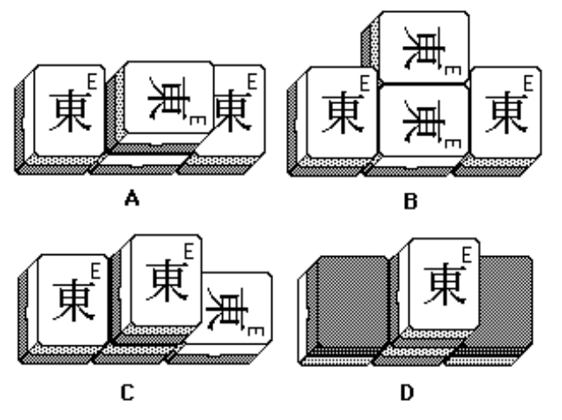
In the illustration above, you can see some methods of displaying Kongs.
A. and B. show two possible ways of displaying a Kong which was made by claiming a discard from the player opposite. Dan can choose whichever one he prefers to use. C. shows how a stacked Kong would look when made by claiming a discard from the player to the right. D. shows how a stacked Concealed Kong looks in Japanese MJ.
The screen shot below gives an idea how rotated Pong/Chow melds would look in our Japanese screen layout. Look at Tom's One Bams and Diane's 5-6-7 Dot chow.

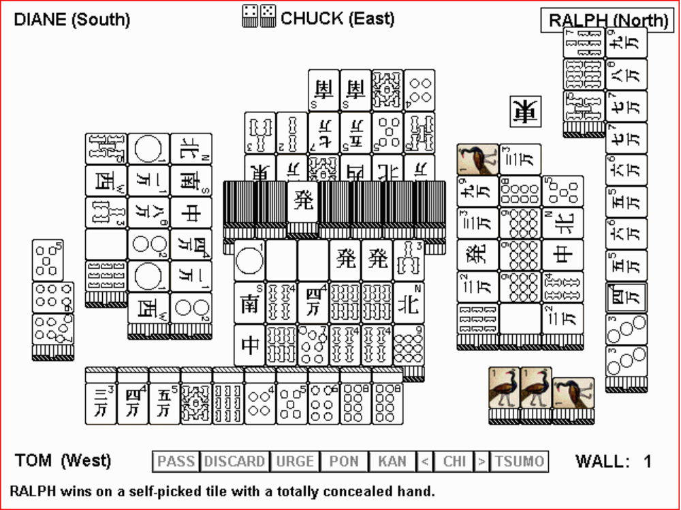

A picture is worth a thousand words, but it seems that every time I draw a picture I have to write a thousand words to point out what the picture is trying to say…
I show the Dead Wall (the 13 face-down and one face-up tiles in the center) as being stacked two tiles deep. Due to the large size of the tiles and the resulting crowdedness of the screen, combined with the thickness of the tiles, this partially obscures some of Chuck's discards. We may want to go with a short Dead Wall (stacked only one tile deep rather than two), and we will want to put the X-Ray button in our button array. I prefer a two-tile deep Dead Wall, but it's feasible to go with one layer.
Note: Japanese MJ limits the game to a total of four Kongs, because of the Dora tile (or maybe it's the opposite -- because the game is limited to a total of four Kongs anyway, that's why the Dora tile is the 3rd from the end of the Dead Wall). In any case, the loose tiles come from the left end of the Dead Wall. If we display a 2-deep Dead Wall, we can display each and every removal of a loose tile. If we display a 1-deep Dead Wall, then we can only show the removal of every other loose tile.
The dice (two of them) are placed next to the current dealer's name.
Note: we do NOT need to display score during gameplay; users can see it between hands. Most Japanese MJ games do not display score during gameplay anyway.
The player on the right went out without ever melding anything (and without having declared "reach"), so no tiles are turned sideways in his hand. MJ pros tend not to meld very often, but our players probably will meld more often than that. Let's take a look at a game with more melds and people declaring "reach" and stuff…

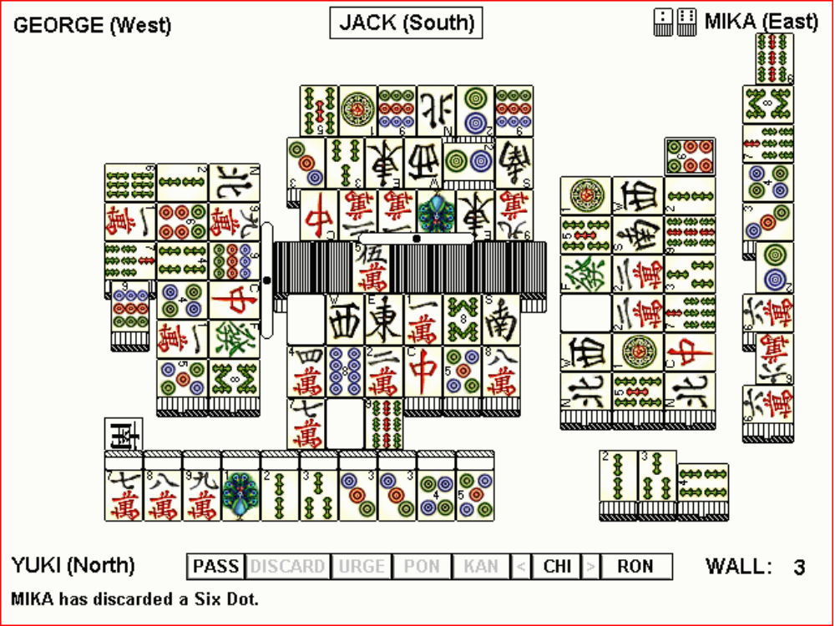

A few things worth mentioning about the above picture.
I have shown the Dead Wall to be only one tile high, instead of two tiles high -- I did this so we can see how it looks. It looks pretty good. It's simply understood that there are 14 tiles in the Dead Wall (the rest of the Wall is not even seen on screen, as we also did not show it in the American/Chinese screen display).
The above-mentioned practice of turning tiles sideways also must occur in the Discard areas, a maximum of once per player in a game. When a player declares "Reach," the discard is turned sideways to mark when in the game this occurred. George and Jack, in the above example, have done this. It tends to alter the shape of the discard area (pushing a tile beyond the boundaries of our neat 6x3 grid); we just have to allow for this.
I have shown the bone markers for the players who have declared Reach. For George, this works fine, because there is a 10-pixel-wide space between his discard area and the end of the Dead Wall. But for Jack, this is a bit messier. He had to place his bone across the top of his discarded tiles (and across part of the Dead Wall), partially obscuring some tiles. There's yet another reason to put the X-Ray button back on this screen, so that the user can see underneath the bone marker. And if we have an X-Ray button, the Dead Wall can be two tiles high (but then we wouldn't be able to see the bone marker). So what we should do is have a one-tile-high Dead Wall -- but the X-Ray button is only needed if the bone marker is concealing Arabic numerals on discards.
Note that a player can only declare Reach if he has an entirely concealed hand -- therefore in such an instance, we will not encounter a sideways tile in conjunction with the occurrence described in the next paragraph.
It is possible that a player will discard more than 18 tiles before the Wall runs out of tiles. It seems to be standard to extend the bottom row of tiles to the right when this happens, so this is what is shown in the picture above. We may have to shuffle things on screen when this needs to occur (and when there are melds in the way). Note that this (having to exceed the normal discard area) only happens to a user who makes an unusually large number of Pongs or Chows during a game, as Mika has done above. Experienced players of Japanese MJ do occasionally call for discarded tiles, but rarely make very many melds during a game.
With a bunch of "amateurs" playing Japanese MJ, we might possibly see many discards, with marked melds in each. The meld areas shown in the screen layout picture at the beginning of this section above should be able to handle all the marked melds a player can make, plus a pair when the player goes out. With such a crowded screen and such large MJ tiles, it will be a challenge to handle this practice of "marking" discards and melds in every conceivable instance. But we just have to deal with it.
One more thing about the above screen shot. Mika has discarded a Six Dot tile, which Yuki could use to go Out; Yuki's Pass, Chow, and Ron (win on discard) buttons are lit up. If Yuki does the "smart" thing and Passes on this tile, Jack's discard area will also gain a 19th tile before the Wall runs out. Why do I say it would be smart for Yuki to pass up Mika's discard? Look closely at Yuki's discards -- there's a Five Dot there. Mika's Six Dot would join Yuki's Five and Four to make a chow, but since Yuki had previously discarded a Five Dot, Japanese rules say that he must not go out on a discard which completes this grouping. It's called "Chonbo" (penalty mistake). This particular mistake is a violation of what Whitney calls "Sacred Discard."
One last point about our screen display which needs to be discussed is Tenpai vs. Noten, and how we display these events. When a Japanese MJ game is played "to the wall," all players' hands are examined to determine who had "Tenpai" and who had "Noten." It is fairly standard to display this status in a very clear video-gamey style, as shown below.

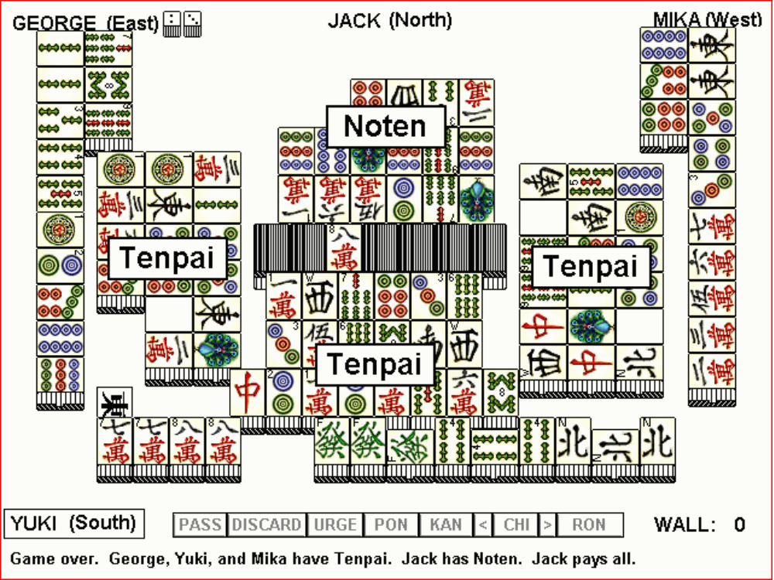

In the Japanese-language version, the Noten/Tenpai boxes above will of course be displayed in kanji or kana so as to look more natural to Japanese eyes.
A few more things worth noting about this picture:
Yuki has discarded twenty tiles. In order to accommodate this, the bottom row had to be shifted left so the 20th tile could be tacked on at the right side. As mentioned above, this messiness is temporary (when a discard area has 18 tiles in it, the end of the game is near anyway).
And if Dan so desires, he can instead stack the 19th and 20th tiles.
George's discard area does not have room for two extra tiles in the bottom row AND a display of his full hand (especially if he makes many melds, which is the circumstance which would cause needing to expand his discard area). So his bottom row (the one on the left side of the screen) would max out at seven tiles -- and the 20th discard would necessitate shifting and wrapping-around to the middle row. Most likely, Dan is the only person who has to understand what I'm talking about, and I can more easily demo this principle in person with some MJ tiles, if I have not explained it clearly enough here.
George's and Mika's pairs are not shown in the "W" position indicated on the initial layout screen because they have not won the game -- their hands are incomplete anyway (only 13 tiles are shown, not 14). A player's hand is revealed at the end when the player has achieved Tenpai (only one tile is needed to win). The only thing I was careful about the positioning of was a complete Pong or Chow in the upper three spaces -- it would be confusing to see, for instance, a pair and 1/3 of a Chow in that isolated location (where George's 7-8-9 Bam chow is, and where Mika's 6-7-8 Dot chow is). Otherwise, the remainder of the tiles are displayed as they would be in a playing hand (as opposed to where they might be displayed if the player had gone out).
Jack's hand is not shown above because he has Noten. Nobody needs to see what he has (it's just junk).

But now I'm going beyond the information needed to fully explain the Japanese screen layout (I think that's now been adequately been conveyed), and am starting to get into the features of Japanese Mah-Jongg. So let's start a new chapter here.

II.3.C.2. Features and Options of Japanese Mah-Jongg

Probably the best way to structure this is by referring the reader to the competitive analysis chart prepared by Ricky Shiraishi and Mas Teranishi. Only 2 competitive products were analyzed: Spicy Szechuan Mah-Jongg (because that program runs on both W95 and Mac, and supports Internet play), and Majan Daigaku (because it's a reasonably good MJ program that runs on W95 and we have a copy).

FEATURE (use numbers to find more detailed explanations farther below in this design) | Shanghai: Dynasty | Spicy Szechuan MJ | Majan Daigaku
1. Scoring starts at 2 Fan (Ba ni ryanhan) | Yes | Yes | Yes
2. 1 Fan minimum (Iihan shibari) | Yes | Yes | Yes
3. Wall plays down to 14 tiles | Yes | Yes | Yes
4. The min. 1 Fan can be created at anytime (Sakizuke ari) | Yes | Yes | Yes
5. "Sacred discard" OK for tsumo (Furiten: Tsumori nara OK) | Yes | Yes | Yes
6. Breaking up an existing grouping for a yaku (Kuikae) | No | No | Yes
7. Feeder pays on Big 3 Drag and Big 4 Winds (Pao-soku) | Yes | Option | Yes
8. Yaku not needed for Tenpai (Keishiki tenpai) | Option | Yes | Yes
9. Dora is the next tile, not same tile | Yes | Yes | Yes
10. Sacred discard (furiten) OK w/ Reach (Furiten reach) | Option | Yes | Yes
11. Pass winning tile for a yaku (Reach-doki no agari sentaku) | No | No | Yes
12. Open Reach (Open Reach) | No | No | Unknown
13. No West round; player with most points is winner | Yes | Yes | Option
14. Kan after Reach OK if winning tile doesn't change only | Yes | Yes | Unknown
15. Kan Dora effective immediately w/ any Kan | Yes | Ankan/ Minkan | Option
16. Kan Dora and Ura Dora | Yes | Option | Option
17. All-Simples hand needn't be fully concealed (Kuitan) | Option | Option | Option
18. Win w/in one turn of Reach (Ippatsu) | Option | Option | Option
19. Penalty for never winning a round (Yakitori) | No | Option | Option
20. Reach money goes to winner (any) | Yes | Yes | Yes
21. Noten Bappu pays 3000 points | Yes | Yes | Yes
22. A chip (300 pts.) each time dealer wins | Yes | Yes | Yes
23. Replay if everybody goes Reach | Yes | Yes | Yes
24. Replay if 3 players Ron same tile | Yes | Option | Option
25. Replay if dealer has 9/9, player has 8/9 or 9/9 w/ tsumo | Yes | Yes | Unknown
26. Replay if all 4 players discard same wind in same turn | Yes | Yes | Unknown
27. Dealer loses deal if not tenpai (exc. Last dealer of S. round) | Yes | Yes | Option
28. Red Fives | Yes | Option | Option
29. 1 game consists of East and South rounds | Yes | Option | Option

1. Scoring starts at 2 Fan -- basically, as long as your winning hand meets the minimum criteria for a legal win, you get 2 Fan for going Out, and other Fan depending on the Yaku in your hand. The 2 Fan for going out is "understood and implied" but never actually displayed on the screen or in the scoring chart.

2. You need a minimum of a 1-Fan Yaku to go Out in Japanese MJ (the 2 Fan that you get for going Out doesn't count). See farther below for the definition of Yaku vs. Fan. After the dealer has 5 win chips, the game's minimum score goes from 1 Fan to 2 Fan (Ryanhan Shibari). See #22, below.

3. Just like in Chinese MJ, the game stops when the Wall gets down to 14 tiles.

4. In this regard, Shanghai: Dynasty will be a little friendlier than some games. Some games don't allow you to make a Chow, then claim a discarded Dragon for a Pong (without having a Reach situation), for example. A hand with a Chow (in Japanese, "Chi") and a Pong, in case this wasn't clear, is normally not a scoring hand -- but Dragon pongs are pretty valuable (will get into scoring later).

5. Whitney explains the "sacred discard" rule. Japanese call this "furiten." Once you have discarded a tile, you cannot subsequently take someone's discard of that same tile to go Out (going Out on a discard is called "Ron") -- if you did this, that would be "chombo" (penalty error). But you may draw that tile again and go Out on it (going out on a self-pick tile is "Tsumo"). There is also an extension of this "sacred discard" or "furiten" rule, called the "1-4-7 rule," which will be explained farther below.

6. Kuikae -- it's not allowed to break up an existing grouping in the hand on another's discard because you see an opportunity to go for a Yaku. Basically, if somebody discards a tile, you claim it and make a meld, then immediately discard a tile that clearly shows that you had a different thing going on, the other players can call you on it and make you take it back under the Kuikae rule. It's okay if you discard that tile later. So Ricky and Mas say that the game either should not allow the user to discard the penalty tile.
Here's an example of Kuikae. Let's say you have an all-Simples hand (Tanyao) except for a 7-8-9 Chi. Somebody discards a 6. It's okay for you to claim the 6 and meld the 6-7-8, but if you discard the 9 immediately, players will tell you "you can't do that" and make you take it back. It's easier for us if we simply disallow the user from discarding the 9 at that moment. Text box should say: "You cannot discard that tile right now. See the 'Kuikae' rule."

7. Pao-soku -- I think "Pao" should be thought of as a verb. To Pao is to feed the last Pong of either a Big Three Dragons or a Big Four Winds hand. Keep in mind that it is possible to meld Big Three Dragons or Big Four Winds and not to have gone Out yet -- you might still have to make a Chi or Pon (in the case of Dragons) or to make a pair ("head") in either case. There are 3 different ways a Pao might have to be paid (in these examples, player A Pao's to player B):
a. By Tsumo -- player B self-picks the winning tile. Player A (who previously gave B his last Dragon or Wind meld) must pay for all.
b. By Ron -- player B takes player A's Dragon or Wind to go Out on B3D or B4W; Player A pays for all.
c. By other's discard -- if player A discards a Wind, player B takes it to make his 4th Wind meld, but still needs to make the pair -- then player C discards the tile player B needs to complete his pair; players C and A split the cost of B's win.

8. Keishiki Tenpai -- under this rule, a fishing/calling hand need not be a nearly-complete high-scoring hand to qualify for Tenpai (it need not be a Yaku hand -- see elsewhere for the definition of a Yaku and how it differs from a Fan). It can be a nearly-complete Chicken hand.
This will now be a user-selectable option. When the rule is On, it's okay to go Tenpai with a Chicken hand. When the rule is Off, you only qualify for Tenpai if your hand is a nearly-complete Yaku hand. That is to say, the fishing hand -- when completed -- would be a yaku hand. The hand does not have to already have a yaku in it in order to qualify for tenpai -- it just needs to be needing one more tile to make a yaku hand in order to qualify for tenpai.

9. Dora tile -- This very important option was apparently introduced in the last 30 years (it is not described in any English-language books about Japanese Mah-Jongg; all such books were written over 30 years ago). After dealing out the tiles, the 3rd tile from the end of the Dead Wall is turned face up. Some people play that the face-up tile is the Dora tile. If a 3-Dot is face-up, you need to get a 3-Dot in order to get the bonus. But since this limits the bonus possibilities to only 3 tiles, most people play (and we will too) that the face-up tile is a Dora indicator instead -- it's the next tile which earns the bonus. For example, if the face-up tile is a Three Dot, and the player goes Out with a chow containing a Four Dot, the player gets one Fan. If the player were to go out with a Pong of Four Dots, the player would score three Fan. The tiles within a suit "wrap around" from Nine to One. The Winds are ordered E-S-W-N (wrap around from North to East), and the Dragons are ordered W-G-R (wrap around from Red to White).

10. Furiten Reach -- This is now to be a user-selectable option. When the option is On, the players are allowed to declare Reach when a Furiten exists. When the option is Off, players cannot declare Reach if a Furiten exists. As explained above, Furiten is a previous discard (discarded by you) which now could be used to complete your hand.
Note: Mas gives this feature/option a Medium priority. If necessary, we could make this always Off (never allowing players to declare Reach with a Furiten) if it saves us programming time.

11. Reach-doki no agari sentaku -- we should enforce the rule that once a player has declared Reach, and any tile appears that could allow the player to go Out, the player must take that tile. Sometimes when waiting for the winning tile, there may be multiple tiles which would allow the player to go Out -- and while any of those tiles is a valid win, one or more of those possibilities may make for a bigger win (one tile might make for a Yaku while another does not). The user may not pass on a valid winning tile which does not make a Yaku, in order to wait for one that does.

12. Open Reach -- sometimes a player will be so confident of getting the tile he needs to win that when he declares Reach, he turns his hand face-up. We aren't doing this.

13. No West round -- This has to do with how to deal with various situations at the end of the last round (Japanese MJ normally consists of 2 rounds these days, per item 29 below). Some rules might do things differently (gameplay cannot stop if nobody has a minimum of 30,100 points, for example, under some people's rules). For Shanghai Dynasty, we'll do as follows (Mas assumes this is easier for Dan): After the end of the South round, play stops and the high-scoring player wins (we do not go into a sudden death West round). Japanese call this rule " Nan Ba Noten."

14. Kan after Reach -- After having declared Reach, it's allowed to make a Kan (Kong), so long as doing so does not change the hand. The implication for us is that the Kong (Kan) button should not light up for a player who cannot legally make a Kong.

15. Kan Dora -- Whenever anyone makes a Kan, the 4th tile from the end of the Dead Wall (the face-down tile right next to the Dora indicator tile) is turned face-up, and is immediately in effect. An important distinction about the Dora tiles -- while a Dora is worth 1 Fan, it does not count as a Yaku. So you may not go Out with a Chicken hand that contains nothing more valuable than one or more Dora tiles.

16. Ura Dora -- at the end of a hand, when a Reach player goes Out, the tile underneath the Dora tile (and, if applicable, the Kan Dora tile) is turned face-up. If the scoring player also has that tile (or should I say the tile indicated by that tile), additional Fans are in effect. Perhaps this is why Dora does not count as a Yaku (somebody could've gone Out if only he'd known what the Ura Dora tile was). It is possible to earn a lot of doubles this way -- Dora, Ura Dora, Kan Dora, and Kan Ura Dora -- and you could earn multiples of one or more, if you have pairs or pongs of the bonus tile.
As for displaying these extra bonus tiles, Ura Doras are only seen after the game is over -- and that area is covered up by our Results box -- so we do not need to actually display tile graphics to communicate Ura Dora to the players. We can simply list it in the Results box. In addition, we should throw a yellow highlight onto the bonus-scoring tiles, in the display of the winning hand.

17. Kuitan -- some people require Tanyao (All Simples) be concealed, but we allow it to be exposed. "Kuitan" refers to the possibility of feeding someone's Tanyao hand.
Side note: Mr. Seno of AJL had pointed out that since it's easier to win under the Kuitan rule (everybody just discards 1's and 9's which are a pain anyway), that he felt that this should be an option rather than a rule (and Mas agrees, since we need options anyway, and since there aren't many choices for options under our austere circumstances). Interesting note: in Tokyo, they always play Kuitan, while in Osaka they never play Kuitan.
This is now a user-selectable option. When the option is On (default), Tanyao can be exposed. When the option is Off, Tanyao must be concealed.

18. Ippatsu -- this refers to a player who goes Out within "one shot" (one turn around the table) of having declared Reach. It makes that turn pretty tense.
This is now a user-selectable option. When it's On (default), the Win button can display "Ippatsu" and if used the player gets a 1 Fan bonus.

19. Yakitori -- many Japanese tile sets come with 4 rectangular pieces (not the same size & shape as a MJ tile) depicting a live chicken on one side and a skewered chicken on the other. When a player goes Out, he turns his tile over. At the end of a game, any player whose chicken is not turned over has to pay a penalty. We won't do this though.

20. The Reach chip (1000 points) -- goes to whoever wins.

21. Noten Bappu (Noten Penalty) -- If the game ends without anyone going out, and if you have "Noten" (you need more than one tile to complete your hand), you have to pay a penalty of 3,000 points to the Tenpai players (those who only need one tile to complete their hands). If two players have Noten, each one pays 1,500. If three players have Noten, each one pays 1,000 to the Tenpai player.

22. Dealer win chip -- When the Dealer wins, a chip is placed in front of him. Whoever wins the next hand gets 300 points for each chip in front of the Dealer. We have to figure out a good way to do this in Shanghai: Dynasty, with our limited table display. Maybe we just make a number near the Dealer's name, instead of chips -- or maybe we make small hash marks. Some games put down one small chip and an X and a number (for example, "chip x 2"). Anything that gets the idea across. After the dealer has 5 chips, the game's minimum score goes from 1 Fan to 2 Fan (Ryanhan Shibari).

23. If all players go Reach, it's an automatic replay situation. Play stops, tiles get shuffled. Dealer goes again (add a chip per #22).

24. If 3 players declare Ron (win by discard) on the same discard, it's an automatic replay. Same as #23.

25. If the Dealer has 9 unique honors and terminals on the initial deal, that's an automatic replay. Same if any player has 8 unique honors and terminals, plus a duplicate of any. Or if any player has 8 unique honors and terminals and draws another unique honor/term on the first draw. As in #23, dealer goes again (add a chip).

26. If all 4 players discard the same wind in one turn around the table, that's an automatic replay. Same as #23.

27. In a Wall game, if the Dealer does not have Tenpai, the Dealer loses the deal. But if it's the last hand of the last round (North dealing, South round), the deal cannot pass to someone else; must remain with that player until hand is won. This rule may be the same thing as the "Noten Oya Nagare" rule, but I'm not positive.

28. Red Fives -- there are 3 normal Five Dots, plus a red Five Dot. 3 normal Five Craks plus a red one, 3 normal Five Bams plus a red one. When a player goes Out with a Red Five, he gets a Fan for that. A Red Five is not good for a Yaku (thus you cannot have an otherwise-Chicken hand with nothing more than a Red Five in it).
This is a Low-to-Medium Priority feature. Thus we will likely not implement it due to time constraints.

29. A complete game consists of only 2 rounds -- East and South as opposed to 4 rounds as is done in Chinese and Western MJ. Some high-roller types like to play that there's only 1 round (East). But it's standard to have 2 rounds. Most Japanese MJ sets have only 2-sided Wind markers (as opposed to the 4 Wind markers in Chinese and American sets).

(30.) An aspect of Japanese MJ which was revealed to me later is one more Replay (Nagare) situation, alluded to in the discussion of the Dead Wall earlier. Upon the removal of the 4th loose tile, when the player who makes a Kong has taken the last loose tile and discarded it, if nobody claims it to win, game automatically stops. Assuming, that is, that the 4 Kongs are not all held by one player. If one player has made 4 Kongs and is now waiting for the "head" tile, play can continue, but nobody can make a Kong anymore. Dan, we can discuss how to handle this in the manner that works best for you.

Now let's consider Yaku. And "Yaku" vs. "Fan." Basically, a Yaku is a way to measure whether a hand meets the minimum scoring criteria or not -- while a Fan is merely a bonus awarded to a winning hand.
Another way of looking at it -- "Yaku" means "rule." Think of a Yaku as a rule defining the minimum requirements for going Out. But a "Fan" (or "Han") is a measure of value for scoring.
If a hand is worth two Yaku, you get two Fan for that. Something that is worth a Fan does not, however, necessarily let you go Out. As mentioned before, while a Dora is worth 1 Fan, it does not count as a Yaku. So you may not go Out with a Chicken hand that contains nothing more valuable than one or more Dora tiles. In addition, a Fan, while being based on the Fan of the Chinese game, doesn't necessarily bestow a double upon the score. The Fans are counted up to help one determine where on the chart one should look to get the hand's score.
In Japanese, Fan is pronounced "Han." Fans are counted in Japanese as follows:

1 Fan = Iihan
2 Fan = Ryanhan
3 Fan = Sanhan
4 Fan = Suhan
5 Fan = Uhan
6 Fan = Rohan (Ryuhan)
7 Fan = Chihan
8 Fan = Pahan

The following are Iihan Yaku (1 Fan) hands:

"Pin Huu" -- Pin Huu (Pinfu in Japanese pronunciation) is an all-Chows hand. To win this special hand, your hand must have no Pong, only Chow. The pair must not be a scoring pair -- it cannot be dragons, nor Own Wind, nor Prevailing Wind. "Pin Huu" is Chinese for "No Points" -- so the player gets the yaku for having a hand that is so worthless that it's worth something! The last tile you take to win the hand must not be a one-chance Chow (it must not be a middle tile, and must not be the other-end tile of a terminal Chow), and must not be a tile to complete a pair (or "head"). In addition, the hand must be concealed. Some players require the last tile to be self-picked, but for our purposes this is not a strict rule. If Pinfu is self-picked, the player gets the extra fan (yaku) for Tsumo On Concealed Hand but does NOT get the extra 2 points for self-pick. Players also get the Tanyao bonus on this hand since it's all Simples. Pin Huu is worth one Yaku.

"Tanyao" -- All simples. Exposed (if allowed because Kuitan is On) or Concealed. One Yaku either way.

"Iipeeko" -- If the hand contains two identical Chows (in one suit), and the hand is concealed, then the player has Iipeeko. One Yaku (Iihan Yaku).

"Sanshoku" -- If the hand contains same-number Chi in all 3 suits, that's Sanshoku. If concealed, it's a Ryanhan Yaku (2 Fan). If exposed, Iihan (1 Fan).

"Chanta" -- All Terminals and Honors. Chows OK. If concealed, Ryanhan Yaku. If exposed, Iihan Yaku.

Pong of any Dragon = Iihan Yaku.

Pong of Own Wind or Prevailing Wind = Iihan Yaku.

"Itsu" -- The hand contains 1 through 9 all in one suit. If concealed, Ryanhan Yaku (2 Fan). Exposed, Iihan Yaku (1 Fan).

"Haitei Tsumo" -- If the player goes Out on the very last tile of the Wall, that's Iihan Yaku (1 Fan).

"Rinchan Kaiho" (Rinshan Kaiho?) -- If the player goes Out on a loose tile, that's Iihan Yaku (1 Fan).
This also applies to another player who draws a loose tile and discards something immediately (that discard is considered a loose tile, even if it is not the exact tile that the player took from the back of the Dead Wall -- it's kind of like an "indirect loose tile"). The thrower of the Kan tile (which set in motion the chain of events leading to the Rinshan Kaiho win) pays for all.

Tsumo on concealed hand -- If you have a fully concealed hand, that's Iihan Yaku.

Riichi -- If you go Out after declaring Reach, that's Iihan Yaku.

The following hands earn Ryanhan Yaku (2 Fan):

"Daburu Riichi" (Double Reach) -- You declare Reach on your original deal (and go Out, of course).

"Itsu" (concealed) -- hand contains 1-9 in one suit. Ryanhan Yaku.

"Sanshoku" (concealed) -- hand contains same-number Chows in 3 suits. Ryanhan Yaku.

"Chanta" (concealed) -- All Terminals and Honors = Ryanhan Yaku.

"Sananko" -- If you have 3 concealed Pongs, you get Ryanhan for that.

"Toi-Toi" -- If the hand is all Pong, that's Ryanhan Yaku (2 Fan). This hand can be exposed. If it's concealed, you also by definition get 2 more Fan for Sananko.

"Shousangen" -- Little Three Dragons. Pongs of 2 Dragons, and a pair of the third. Ryanhan Yaku.

"Sanshoku Dokou" -- Same-number Pongs in 3 suits. Exposed. Ryanhan Yaku.

3 Kans -- any 3 Kongs = Ryanhan Yaku.

"Honrouto" -- All Terminals, Dragons, & Winds = Ryanhan Yaku. You would also earn 2 more Fan for having Toi-Toi with this one.

"Sanrenko" -- 3 sequential Pongs in one suit (could also be thought of as 3 matching Chows in one suit) = Ryanhan Yaku.

"Chi To Itsu" -- 7 pairs = Ryanhan Yaku.
The following hands earn Sanhan (3 Fan):

"Ryanpeeko" -- Having Iipeeko (2 identical Chows) in 2 suits. Must be concealed.

"Honitsu" -- Clean hand. One suit, plus Winds and/or Dragons. Concealed = Sanhan Yaku. Exposed = Ryanhan Yaku.

"Junchan" -- Terminals only. Under Japanese rules, it's OK for the hand to include Chows with a Terminal at one end. Concealed = Sanhan. Exposed = Ryanhan.

The following hand earns Rohan (6 Fan):

"Chinitsu" -- Pure hand. Concealed = Rohan (6 Fan). Exposed = Uhan (5 Fan).

The following situation earns Mangan (Limit):

"Nagashi Mangan" -- You automatically get this if all your discards are Honors and Terminals, and no other player takes any of your discards and it's a Wall Game. All the tiles run out -- nobody won, nobody took any of your discards even though all your discards were Honors and Terminals -- you automatically win.

We need to discuss scoring now -- then we'll get into the Limit Hands (Yakuman and Double Yakuman) later…

SCORING JAPANESE MAH-JONGG

Scoring is very similar to how we already do it in Chinese and Western, for starters, but with some extras:

Going Out, Exposed 20 base points
Going Out, Concealed 30 base points (applies to non-Dealer)
Going Out on discard 30 base points
Going Out on 7 Pairs 25 base points
Going Out on Self-Pick 2 points
One-Chance 2 points
Pong/Simples, Exposed 2 points
Pong/Simples, Concealed 4 points
Pong Honor/Term, X 4 points
Pong Honor/Term, C 8 points
Kan/Simples, Exposed 8 points
Kan/Simples, Concealed 16 points
Kan Honor/Term, X 16 points
Kan Honor/Term, C 32 points
Pair of Dragons 2 points
Pair Own or Prev. Wind 2 points

An important fine detail: when you go Out on someone's discard, the grouping completed by the discard is considered to be exposed (for scoring purposes). The hand itself, however, is still regarded as concealed if no melds were made prior to going Out.

Here's a scoring example -- Non-Dealer gets TOI-TOI (All Pong) by someone's discard:

2 exposed pongs of Simples 4
1 concealed pong of Simples 4
1 concealed pong of Terminals 8
Subtotal 16
Round it up 20
Going Out, Exposed + 20
Total points 40

Now go to the Non-Dealer chart (farther below). Go to the 40-points column.
Now all you have to do is know how many Fan (so you know which row). Note: although it is implied and understood that players get 2 Fan for going Out, it is never actually shown (I guess that's built into the numbers in the scoring chart):

Toi-Toi + 2 Fan
Total Fan 2 Fan

So in the 40-points row, move down to the 2 Fan row (Ron section, since it was a discard and only one player will pay).

Score 2600

That's how much the thrower pays.

Special case -- PIN-HUU with Tsumo (self-pick) -- The Tsumo is worth 2 points, but "Pin-Huu" literally means "no points." You get a higher score for Pin-Huu anyway, so the Tsumo points are not awarded when you get Pin-Huu.

In Shanghai Dynasty's results box, we do not need to show all the detail above. Japanese players only care how many Fan, and how many Points result at the end. So display similarly to our first results box, but leaving out the calculation of the base points. Just show the base points and break down the Fan and Yaku as follows:

Iipeeko 1 Fan
Ippatsu 1 Fan

Points 40
Fan 2
Score 2600

We can still show the names of the 4 players at the top of the 1st results box, showing who pays what. And the 2nd results box can also stay as it is (note that the numbers will now have more digits.
At the end of the game, we will need a third results box to show the game's final results. Players must be ranked First, Second, Third, and Last.
At the end of the game, the score (until now measured in thousands) is converted into smaller units. Mainly this is done so that if the players are gambling, they know how much to pay one another. Most Japanese players will expect to see the endgame score displayed in one- or two-digit numbers.
Players start the game with 25,000 points. At the end of the game, players are ostensibly supposed to attain 30,000 points (I call this "goal"). Some games let you vary the start amount and/or the goal. We just stay with 25,000 and 30,000.
1. Players' final scores are compared with the goal of 30,000 and it is determined how far off the mark they are. For example, if a player winds up with 35,000, then he's 5,000 ahead; if a player winds up with 24,000, then he's minus 6,000.
2. The player with the highest score is awarded the difference between the start points and goal for each player around the table (20,000 is added to his score).
3. Each player's score is divided by 1,000. If a score is not evenly divisible by 1,000 then the score has to be rounded first. If the "fraction of 1,000" is 500 or more, round up. If 400 or less, round down. For example, if a player had end score of 35,000 and then was awarded 20,000, his final score is +25 (20,000 winnings added to the amount of points over 30,000).
4. When players are gambling, then multiply the final score times the previously-agreed monetary unit (usually either ¥100 or ¥1,000) to arrive at the payment amount. In the following example, I assume ¥100 payment. NOTE that in Shanghai Dynasty, we do not care about the bottom row of this chart (I only include it to be complete).

Start | 25000 | 25000 | 25000 | 25000
Goal | 30000 | 30000 | 30000 | 30000
Endgame score | 35000 | 26000 | 15000 | 24000
Difference from goal | +5000 | -4000 | -15000 | -6000
Winnings | +20000
Total score | +25000 | -4000 | -15000 | -6000
Monetary units convert | +25 | -4 | -15 | -6
Monetary payment | +¥2500 | -¥400 | -¥1500 | -¥600

It would be nice to show this final calculation (above), minus the bottom row, in the final results box. The following information absolutely must be displayed in the final results box:

Player | Tom | Dan | A.I. #1 | A.I. #2
Rank | Last | First | Third | Second
Final score | -15 | +25 | -6 | -4

In fact, this ranking is important strategically. Players need to be able to tell between hands which player is ahead and which one is last (although we needn't display these rankings as such -- rankings can be inferred from the current score).
Now here are the charts. We will probably include these charts in the manual, but the player never needs to be shown this in the game itself (other than possibly in the Rules & Strategy).

SCORING CHART -- DEALER

 |  | 20 pts. | 25 pts. (7Pairs) | 30 pts. | 40 pts. | 50 pts. | 60 pts. | 70 pts.
Tsumo | 1 Fan |  |  | 500 | 700 | 800 | 1000 | 1200
Tsumo | 2 Fan | 700 |  | 1000 | 1300 | 1600 | 2000 | 2300
Tsumo | 3 Fan | 1300 | 1600 | 2000 | 2600 | 3200 | 3900 | 4000
Tsumo | 4 Fan | 2600 | 3200 | 3900 | 4000 | 4000 | 4000 | 4000
Tsumo | 5 Fan | 4000 | 4000 | 4000 | 4000 | 4000 | 4000 | 4000
Ron | 1 Fan | 1000 |  | 1500 | 2000 | 2400 | 2900 | 3400
Ron | 2 Fan | 2000 | 2400 | 2900 | 3900 | 4800 | 5800 | 6800
Ron | 3 Fan | 3900 | 4800 | 5800 | 7700 | 9600 | 11600 | 12000
Ron | 4 Fan | 7700 | 9600 | 11600 | 12000 | 12000 | 12000 | 12000
Ron | 5 Fan | 12000 | 12000 | 12000 | 12000 | 12000 | 12000 | 12000

The Tsumo section shows how much each player pays the Dealer. The Ron section shows how much the thrower pays the Dealer.

SCORING CHART -- NON-DEALER

 |  | 20 pts. | 25 pts. (7Pairs) | 30 pts. | 40 pts. | 50 pts. | 60 pts. | 70 pts.
Tsumo | 1 Fan |  |  | 300  500 | 400  700 | 400  800 | 500  1000 | 600  1200
Tsumo | 2 Fan | 400  700 |  | 500  1000 | 700  1300 | 800  1600 | 1000  2000 | 1200  2300
Tsumo | 3 Fan | 700  1300 | 800  1600 | 1000  2000 | 1300  2600 | 1600  3200 | 2000  3900 | 2000  4000
Tsumo | 4 Fan | 1300  2600 | 1600  3200 | 2000  3900 | 2000  4000 | 2000  4000 | 2000  4000 | 2000  4000
Tsumo | 5 Fan | 2000  4000 | 2000  4000 | 2000  4000 | 2000  4000 | 2000  4000 | 2000  4000 | 2000  4000
Ron | 1 Fan | 700 |  | 1000 | 1300 | 1600 | 2000 | 2300
Ron | 2 Fan | 1300 | 1600 | 2000 | 2600 | 3200 | 3900 | 4500
Ron | 3 Fan | 2600 | 3200 | 3900 | 5200 | 6400 | 7700 | 8000
Ron | 4 Fan | 5200 | 6400 | 7700 | 8000 | 8000 | 8000 | 8000
Ron | 5 Fan | 8000 | 8000 | 8000 | 8000 | 8000 | 8000 | 8000

In the Tsumo section, the Dealer and 2 non-Dealers will pay the winner. The top number is the non-Dealer payment amount; the bottom number is the Dealer payment amount. In the Ron section, the number indicates how many points the thrower pays the winner.
The entire 5-Fan row, half of the 4-Fan row, and one square of the 3-Fan row, is a "Limit" (Mangan) zone on the chart (the shaded area). You may notice that at 30 points and 4 Fan, the payment is nearly the same as if the winner had gotten "Mangan" (Limit). Since 7700 or 7900 is so close to 8000, it is simply called Mangan and the two non-dealers pay the limit (4000 points). Similarly, if a dealer scores 11,600, that is regarded as being Mangan ("Limit"). These special "close enough" scores are highlighted in a lighter shade of gray on the chart above.
But Mangan is not, truly, the Limit. It is possible to score even higher than that…

SCORING CHART -- LIMIT HANDS

If the winner gets more than 5 Fan, don't even bother with the base points. Just use this chart. Haneman is one and a half times Mangan. Baiman is Mangan times two. Sanbaiman is triple Mangan. Yakuman is quadruple Mangan.

4-5 Fan | Mangan (other charts) | Dealer receives: | Non-dealer receives:
6-7 Fan | Haneman | 18000  (6000 each player) | 3000 (each non-dealer)  6000 (dealer)
8-9-10 Fan | Baiman | 24000  (8000 each player) | 4000 (each non-dealer)  8000 (dealer)
11-12 Fan | Sanbaiman | 36000  (12000 each player) | 6000 (each non-dealer)  12000 (dealer)
13 Fan and up | Kazoe Yakuman | 48000  (16000 each player) | 8000 (each non-dealer)  16000 (dealer)

If anybody is interested (or even if they aren't), my big 7 Pairs hand in Tokyo last October was scored as a Haneman hand.

Reach 1 Fan
Chi To Itsu (7 Pairs) 2 Fan
Pair of Dora 2 Fan
Pair of Ura Dora + 2 Fan
Total 7 Fan = Haneman

The following hands earn Yakuman:

"Chuurenpooto" -- Nine Gates. Pongs of Ones and Nines, plus 2-3-4-5-6-7-8 and any one tile, all the same suit.

"Little Four Winds" -- the winner's Own wind is allowed to be either a Pong or the Pair (Head).

"Big Three Dragons"

"All Kong"

"All Green" -- This Japanese hand encompasses "Jade Hand" and "Royal Jade." The Green Dragons are optional -- they can be used for a Pong or a Pair, or not be used at all.

"Chinrouto" -- All Terminals.

"All Winds & Dragons"

"Unique Wonders" ("Thirteen Orphans" or "Thirteen Impossible") -- this is the only hand with which Robbing the Kong is allowed in Japanese MJ. Any tile may be taken by Robbing the Kong (not only the duplicate).

Four Concealed Pongs of anything.

Clean Pairs.

Four consecutive Pongs -- Kongs are OK.

"Chiho" -- Earthly Hand. You go Out by self-pick within the first turn.

"Renho" -- going Out on a discard within the 1st deal (does not apply to the Dealer).

The following earn Double Yakuman:

"Tenho" -- Heavenly Hand.

"Big Four Winds"

"Unique Wonders / Thirteen Orphans" -- and waiting for the one duplicate tile (9 ways to win).

"Chuurenpooto" -- and waiting for the duplicate tile.

4 Concealed Pongs -- and waiting for the one tile to complete the pair.

In case you're wondering, it's even possible to get combinations that give you Triple Yakuman and more. The ultimate is Yakuman Times Seven. For example, you might get something like:

All Winds & Dragons Yakuman
Big Three Dragons Yakuman
Waiting for the pair Double Yakuman

However, if it saves programming time, we could just limit the maximum award to Double Yakuman.

PENALTIES ("CHONBO")

There are many different ways you can make a penalty mistake (Chonbo or Chombo). Which is why I made them so often when playing Japanese MJ, I guess. Here they are:

- You declare Reach, then miss a chance, and have to display your hand in a Wall game because you have Tenpai (and everybody discovers that you had missed a chance). If possible, we should just prevent users from making this one.
- You have three of a kind, plus one tile above or below it (and otherwise your hand is complete). This gives you three chances to go Out, and it's very easy not to see them all. If you ever discarded one of those three possible tiles and go Out on a discard, that's Chonbo.
- Any missed chance while in a Reach situation. Ideally, this won't even be possible in our game.
- Any missed Waiting (Fishing, Calling) before your turn again. Kind of like the "Reach-doki no agari sentaku" rule. If somebody discards a tile you need, then you pass it up, then before it's your turn again, somebody discards another tile you need and you take it, people will know -- and it's Chonbo. Here's an example. Let's say you have (all in one suit) 2-3-4-4-5-5-5-6-6-7-7-8-8. You have 5 chances to win: 1,3,4,6,9. Of those chances, the ones that get you the best Yaku are the 3 or the 6 (you figure it out). Maybe you noticed that the 3 and the 6 were good tiles to go Out on, but didn't realize that the 9 was too -- somebody discards the 9 and you don't take it. Then, before it's your turn again, you take a discarded 3. That's Chonbo. Big penalty. Some more examples of how hard it is to see all the chances on a Pure hand: 1-2-3-4-5-5-5-6-6-7-8-9 (5 chances); 2-3-4-4-4-5-5-5-6-6-6-7-8 (7 chances); and of course 1-1-1-2-3-4-5-6-7-8-9-9-9 (9 chances).
- Claiming someone's discard to make a below-minimum hand.
- Going Out with a below-minimum hand. Note that normally the minimum is One Fan. But when the Dealer has won 5 hands (has 5 chips in front of him) the minimum automatically changes to Two Fan.
- Violating the Sacred Discard (Furiten) rule, or the 1-4-7 rule. It can be very easy to violate these rules, especially if your discarded tile had been taken by someone. Just looking at the discards is not a guaranteed way of making sure you don't violate the rule; maybe there's something in somebody's melds. More on the 1-4-7 rule below.

The 1-4-7 Rule
The 1-4-7 rule expands the definition of the Furiten to include other tiles which could complete a Chi made from the "sacred discard." Under the 1-4-7 rule, if you had previously discarded a 6 Dot, then later have an incomplete Chi which needs a 6 (such as a 4-5 or a 7-8), then not only is the 6 Dot "sacred," but you must not claim a 3 or 9 either. In fact, the player should get rid of the incomplete set entirely if he ever hopes to claim a discard for a win.
Here is an example of the 1-4-7 rule: Let's say you have the following tiles:

C4-C5-C6-B4-B5-B6-D4-D4-D4-D5-D6-D7-D8

On this hand, you have 5 chances to win (all Dots): D3-D5-D6-D8-D9. The 4-5-6-7-8 combo especially is significant, because it gives 3 chances to win (3-6-9). 3-6-9 is conceptually the same thing as "1-4-7." Three tiles any one of which complete a sequence of five and turns it into two Chows.
Let's say you had discarded a D8 previously. If somebody else discards, say, a D6, you had better not take it (or any of those Dots which could give you a win) -- they are all connected. It's not ONLY the previously discarded tile itself which is "sacred," under the 1-4-7 rule.

The "Sacred Discard" or Furiten rule is STRICT!!
In fact, it is a rule of Japanese Mah-Jongg that if a player has a Furiten out there, he had better not claim ANY discard to go out. As I understand it, if the tiles you need to win include a tile you had discarded, then do not claim ANY discard for a win. You can self-pick (according to the "Furiten Tsumori Nara OK" rule), OR you can divest yourself of tiles so that the tiles you need to win do not include a tile you previously discarded. We have to enforce this rule. Here's an example. Let's say you have:

W-W-B4-B5-B6-C4-C5-C6-D4-D5-D6-D4-D4

You have 3 chances to win: W, D4, or D7. But if you had previously discarded a West wind, you had better not claim any of these 3 chances for a win. You can either get rid of the West winds (thus they are no longer needed to win) or you can just hold out for Tenpai at the end.

CHOMBO PENALTY PAYMENT
The penalty for making Chombo is the Mangan amount. See the scoring chart. If non-dealer makes Chombo, he pays 8,000 points: 4,000 to the dealer and 2,000 to the other players. If dealer makes Chombo, he must pay 12,000 points: 4,000 to each player.

II.3.C.3. User-selectable Options in Japanese MJ

Originally, I instructed Mas and Ricky to go easy on the options -- if stuff could be either an option or a feature, it needed to be a feature. Most Japanese MJ games are rife with tons of options -- options add programming/debugging time. Then when Mas gave me the list of options, we prioritized features and options. There were suddenly no options. In order to be competitive with other Japanese MJ products, it was necessary to turn some of our features into options. So here they are.

JAPANESE MAH-JONGG OPTIONS

IPPATSU
FURITEN REACH
KUITAN
KEISHIKI TENPAI
RESET TO DEFAULT

IPPATSU
If a player declares Reach, then, within one round, goes Out, he has achieved Ippatsu. Not sure how we should translate this term into English (or even if doing so is advisable/desirable).
Here's a bit of info about Reach itself:
First, the hand must be totally concealed. If you have melded anything, you cannot declare Reach. When you find yourself in a position in which you need only one tile to go Out, and your tiles are concealed, (and, if Furiten Reach is not allowed, you have not made a "sacred discard"), then you may declare "Reach." At this time you freeze your hand -- you are not allowed (in our case, you will not even be able) to make any modifications to your hand -- you can only discard everything that comes up if it is not the one (or more) tile that you need to go Out. You place a bone marker along the top of your discards -- this is a bet of 1,000 points. You turn your discard sideways to mark when you went Reach.
If playing against all A.I. opponents, (in which case the game progresses very quickly and the game notifies you of any useful tiles that come up), we may want to let the game even draw and discard automatically -- since you cannot do anything with any tile except a winning tile anyway. GAM's MJ game works this way, and it seems appropriate to me.

FURITEN REACH
Determines whether or not you can declare Reach if you have made a "sacred discard" (Furiten). If this rule is Off, you are not allowed to declare Reach (the game will not allow it) if any of your discards are among the list of possible tiles which would allow you to go Out. Default setting is On (you are allowed to declare Reach if there is a Furiten). If it is easier to just implement Furiten Reach as a feature then maybe we don't make this an option -- but the game needs at least 4 options to be competitive.

KUITAN
Determines whether the Tanyao hand can be exposed or not. If Kuitan is Off, then the hand must be concealed.

KEISHIKI TENPAI
Determines whether or not a hand can qualify for Tenpai. When the option is On, the hand need not be a fishing Yaku hand; it can be a fishing "Chicken" hand. When the option is Off, the hand must not only need only one tile to win, but must be a fishing Yaku hand to boot.

Important note: if the above options are too difficult to implement as Options (but can be more easily implemented as Features), and if there are other features on the Features chart which are known to be Options of competitive products and which are more easily implemented as Options than as Features, then we can change the Options list above accordingly.

Glossary of Japanese MJ Terms

1-4-7 Rule -- Not only can a player not take a tile which he discarded, he also cannot take a tile which would complete the same set that the discarded tile would have completed. Detailed explanation on page 73, Whitney.

All Green -- Green Bamboos (Green Dragons may also be included in any combination).

Ankan -- Who cares? Not applicable in Shanghai: Dynasty.

Ari -- Synonym for "Have" or "On" or "Yes" depending on context.

Ba Ni Ryanhan -- Fan scoring begins with 2 Fan (automatically start with 2 Fan, then add earned Fan).

Baiman -- Loosely could be interpreted as "Triple Limit" but actually refers to a hand that scores 10, 11, or 12 Fan.

Chanta -- All Terminals and Honors hand.

Chi -- Chow. Sequence. Run.

Chi To Itsu -- Seven Pairs hand.

Chihan -- 7 Fan.

Chiho -- Earthly Hand. You're not the Dealer, and you go Out by self-pick within the first turn.

Chinitsu -- Pure hand.

Chinrouto -- All Terminals hand.

Chombo -- Penalty mistake.

Chonbo -- Alternate spelling for "Chombo."

Chuurenpooto -- Nine Gates hand.

Daburon -- Double Ron. This feature is not being supported in Shanghai Dynasty. Which is a good thing, because if the rule is supported, then there are complicated options which we'd have to deal with (how to pay if two Reach players both claim Ron). In the absence of Daburon, conflicting claims for Ron are resolved the same as is done in Chinese and Western MJ.

Daburu Riichi -- Player declares Reach on the original deal, and subsequently goes Out.

Dobon -- Not supported. Has to do with what happens when a player's score goes below zero.

Double Reach -- alternate spelling for "Daburu Riichi."

Fan -- In Chinese MJ this means "Double" but in Japanese MJ this is more like "Superpoint" or "Megapoint" -- used in scoring the hand.

Furiten -- Sacred Discard (see).

Furiten Reach -- I guess this refers to the state you're in after declaring Reach, and a tile you could use to win has been discarded by you previously? Will confirm with Mas and Ricky.

Furiten: Tsumori Nara OK -- It's OK to go Out on a Sacred Discard after declaring Reach, only if you draw it from the Wall.

Haitei Tsumo -- Going Out on the very last tile of the Wall.

Han -- Japanese pronunciation of "Fan."

Haneman -- Could be loosely considered to mean "Double Limit" but actually refers to a hand that scores 8 or 9 Fan.

Head -- The Pair of tiles needed to complete a hand.

Honitsu -- Clean hand.

Honrouto -- All Terminals and Winds hand.

Iihan -- 1 Fan.

Iihan Shibari -- 1 Fan Minimum score required to go Out. Note that this actually refers to the hand's "Yaku" value. Dora and Red Fives are worth one Fan each, but are not worth a Yaku. The hand must score a Yaku of at least One in order to qualify, no matter how many Fan the hand is worth.

Iipeeko -- Hand containing two identical Chows in same suit (concealed).

Ippatsu -- Going Out within one turn of having declared Reach.

Itsu -- One through Nine in same suit.

Junchan -- Terminals Only. Different from the "All Terminals" hand in that it's OK to have Chows with a Terminal at one end to qualify for Junchan.

Kan -- Kong. Quad. Four Of A Kind.

Kan Dora -- The 4th tile from the end of the Dead Wall. This tile is turned over instantly when anyone makes a Kan. If a player goes Out with the next tile following the Kan Dora, that player gets one Fan for the tile.

Kazoe Yakuman -- Usually simply referred to as "Yakuman." The ultimate attainable score (loosely can be considered the same as a "Royal Flush") -- in actuality it's possible to even get "Double Yakuman."

Keishiki Tenpai -- In order to qualify for Tenpai, the hand need not be a fishing Yaku hand. It can be a fishing "Chicken" hand.

Kuikae -- Taking a discard and breaking up an existing grouping in the hand in order to attempt to increase the hand's value, then immediately discarding a tile which everybody can see had been part of a different (less valuable) grouping.

Kuitan -- "Tanyao" (an All Simples hand) can be Exposed (whereas some players require this special hand to be Concealed).

Little Four Winds -- As opposed to the Big Four Winds hand, Little Four Winds consists of 3 pongs of Winds and a "head" (pair) of Winds. In Japanese rules, it does not matter whether the pair is the player's Own Wind or not, since the bonus for Own Wind is a separate matter.

Mangan -- A hand which scores 6 or 7 Fan. Can be thought of as a "Limit" hand, but there are higher-scoring hands possible.

Minkan -- Who cares? Not applicable to Shanghai: Dynasty.

Nagashi Mangan -- Automatic "Limit" hand of All Honors And Terminals, without any other player having taken any of your discards.

Nan Ba Noten -- South Player has Noten. We just end the game at the end of the South round (there is no sudden death West round -- high scorer wins).

Nanyuu -- I have received conflicting definitions of this unsupported rule, so I'm not attempting to figure out which definition is correct.

Nashi -- Word synonymous with "Off" or "Don't have" or "No," depending on the context.

Noten -- A hand needing more than one tile to win when the Wall is only 14 tiles. A hand which has not even attained the lowly status of "fishing Chicken" hand.

Noten Bappu -- The penalty payment for not having attained Tenpai by the time the Wall reaches 14. In our game, this equals 3000 points (paid jointly by all Noten players) which is split up evenly and disbursed to all the Tenpai players.

Noten Oya Nagare -- If the Dealer does not have Tenpai, the deal passes along. This rule refers to what to do when it's the last hand of the round (I think). This rule seems to be the opposite of the Nanyuu rule (at least, according to one definition of Nanyuu). Don't worry about it.

Pahan -- 8 Fan.

Pao-Soku -- Thrower who causes someone to win by means of Big Three Dragons or Big Four Winds must pay for all (or pay half if someone else throws the tile needed to complete the pair).

Parenchan -- Feature not supported in Shanghai: Dynasty. Has to do with somebody winning 8 hands in a row.

Pin Huu -- "No Points" hand. All Chow. Last tile must not be a one-chance tile (Chow or pair).

Pon -- Pong. Triple. Three Of A Kind.

Reach -- A declaration made at the time of placing a bet on going Out with a fully concealed hand. This bet can only be made when the hand needs only one tile to be complete (that one tile might be any of several different tiles). If you had a Chow of Bams and three Pongs of E-W-S Winds and a single North Wind, clearly the only tile you could take to go out (for "Little Four Winds") would be a North Wind. If you had two Pongs of E-S Winds and two pairs of N-W Winds and a Chow of Bams, then you need either a N or a W to win. In either case, you can declare Reach at the time of discarding an unwanted Dot tile, for example. If you don't declare Reach at the first opportunity, you can declare it on a subsequent discard.

Reach-Doki No Agari Sentaku -- Once you have declared Reach, you must take any discarded tile which legally completes your hand, no matter the value of the complete hand (you are not allowed to pass a valid winning discard).

Red Fives -- One Five Dot, one Five Crak, and one Five Bam are painted with only red paint (no green or blue). Player gets one Fan for each Red Five in the winning hand. Does not count towards a Yaku (if the hand does not contain anything more valuable than a Red Five, the hand does not qualify for the minimum One Fan score).

Renho -- Roughly equivalent to the Earthly Hand (less valuable than the Heavenly Hand). Whereas to qualify for Earthly Hand, the player must self-pick the winning tile within the first turn of the deal, if the player takes a discard to go Out within the first turn of the deal, that's considered "Renho."

Riichi -- More correct spelling for the Japanese pronunciation of the English word "Reach." See "Reach."

Rinchan Kaiho (Rinshan Kaiho) -- Going Out on a loose tile (a tile taken from the back of the Wall after a Kan).

Rohan -- 6 Fan (also called "Ryuhan").

Ron -- Going Out on someone's discard. The discarder will pay for all.

Ryanhan -- 2 Fan.

Ryanhan Shibari -- 2 Fan minimum score (note that this actually refers to the hand's Yaku value -- the hand must contain a Ryanhan Yaku, not just 2 Dora tiles or 2 Red Fives) which kicks in when the dealer has won 5 hands.

Ryanpeeko -- Hand with 2 identical Chows in one suit, and 2 identical Chows in another suit as well. Concealed.

Ryuhan -- 6 Fan (also called "Rohan").

Sacred Discard -- A tile which had previously been discarded but which the player now needs to complete the hand. Japanese term is "Furiten."

Sakizuke Ari -- The "Sakizuke" rule ("Ari" meaning simply "On" or "OK") allows the player to turn the tide in midstream, so to speak. An apparently valueless hand can be suddenly made to have a Yaku value at any time during play.

Sananko -- Three concealed Pongs.

Sanbaiman -- A hand that is worth 13 or 14 Fan (one step below Yakuman).

Sanhan -- 3 Fan.

Sanrenko -- Three sequential Pongs in one suit (could also be regarded as 3 identical Chows in one suit).

Sanshoku -- Same-number Chi in all three suits (can be thought of as three sequential "knitted" Pongs).

Sanshoku Dokou -- Same-number Pongs in three suits (kind of like three identical "knitted" Pongs).

Shousangen -- Little Three Dragons. Two Pongs of Dragons, and a pair ("Head") of Dragons.

Suhan -- 4 Fan.

Tanyao -- All Simples hand.

Tenho -- Heavenly Hand. Dealer goes Out on his original deal.

Tenpai -- A hand which is "fishing" at the moment that the Wall reaches 14.

Thirteen Orphans -- "Unique Wonders" hand; "Thirteen Impossible." One of each Terminal, Wind, and Dragon, plus a duplicate of any tile. Worth double if player goes Out on the duplicate. This is the only hand for which Robbing the Kong is allowed.

Toi-Toi -- All-Pong hand.

Tsumo -- Going Out on a self-picked tile.

Uhan -- 5 Fan.

Uma -- Some players add a point spread into the endgame results (just prior to converting the final 1- or 2-digit score into money). We are foregoing this feature in Shanghai Dynasty (Mas suggested it as an Option, but assigned it a Medium priority; we don't have time, so it's out). If we were to include this feature, we would also need to give players choices for the point amounts in the spread. Just for completeness, let me give some details here. The recommended spreads are 5-10, 10-20, and 20-40. (5-10 is default.) Top player gets +10, 2nd player gets +5, 3rd player gets -5, last player gets -10. So in our chart elsewhere in this design, we would add one more row…

Monetary units | +25 | -4 | -15 | -6
Uma point spread | +10 | +5 | -10 | -5
Monetary payment | +¥3500 | +¥100 | -¥2500 | -¥1100

Ura Dora -- The tile under the Dora tile ("Ura" means "Under").

Wareme -- This is an optional feature which we are foregoing in Shanghai Dynasty(Mas suggested it as an Option, but assigned it a Medium priority; we don't have time, so it's out). The player whose Wall is broken at the start of play stands to earn or pay double at the conclusion of the hand. In Shanghai Dynasty we don't show the physical Wall, but players would be able to know which player is the Wareme player by means of knowing what number show on the dealer's dice (they could count around the table) -- or, if we were doing the feature (but we aren't), we could highlight the Wareme player's name in red.

Yaku -- Needed to complete a winning hand. A Yaku can be worth anywhere from one Fan on up. Not everything that is worth a Fan qualifies as a Yaku (for example, Dora or a Red Five do not constitute a Yaku).

Yakuman -- See "Kazoe Yakuman."

1-2-4-5-6-8-9

